Volume 1
Welcome to the LWVBloomington Newsletter 2024

February 6, 2024 Member meeting
Wow! The February member meeting was a not-to-be-missed educational event! Paul Huffman, Elections and Redistricting Coordinator for the State League presented information on a new bill that will redesign how redistricting decisions are made. Redistricting is one of the State League’s 2024 legislative priorities. Our Bloomington League is dedicated to educating our members on this complex topic.
There was engaged dialogue and thoughtful questions. Did you miss it? His slide deck is posted on our website.
https://www.lwv-bloomington.com/past-news-events
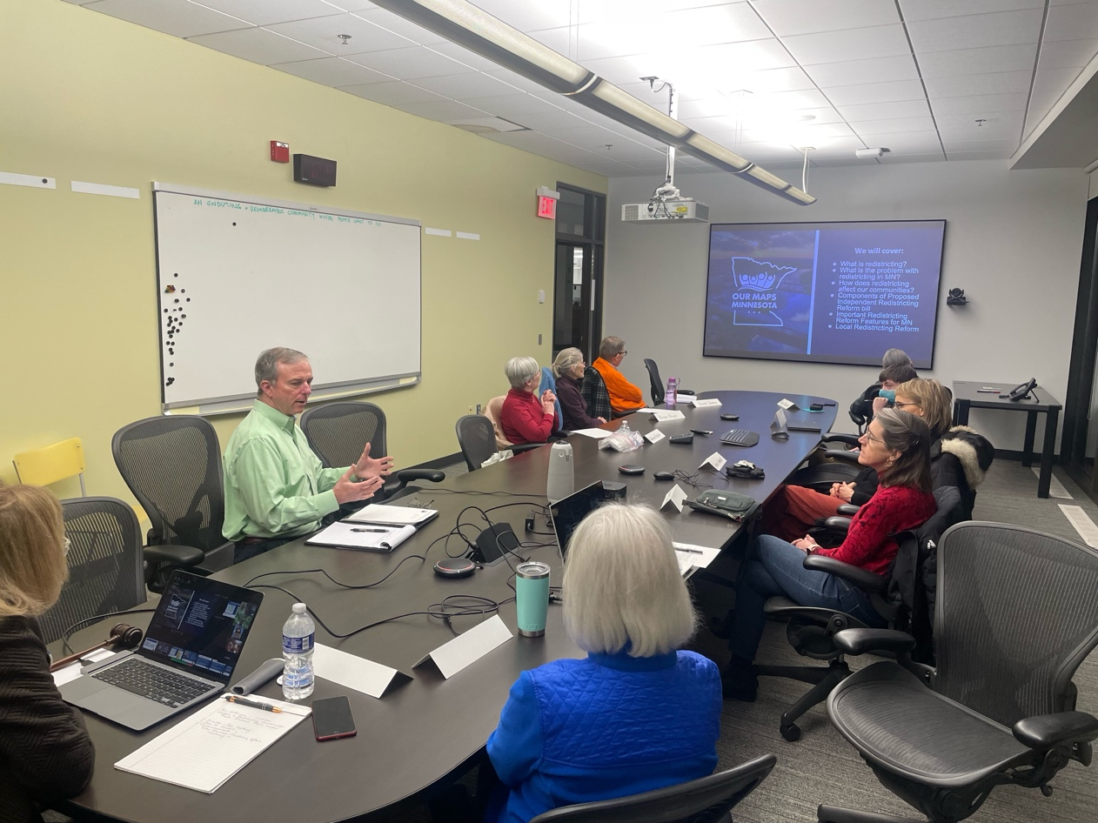

December Annual Meeting and Election of Board and Officers
December 5, the annual meeting was held at the rehearsal hall at Civic Plaza. We had 32 members and guests attend and bring a wonderful variety of tasty treats and foods. Corinne Shepherd presented the annual report which is a compilation of the 2023 accomplishments of our League. A copy of the report can be found here:
https://static1.squarespace.com/static/58a9da299f74561f4dbe41ad/t/6570a4390822e126e269d2e3/1701880964968/2023+LWVBloomington+Annual+Report.pdf
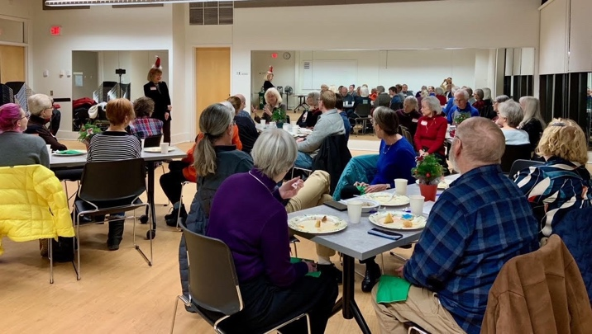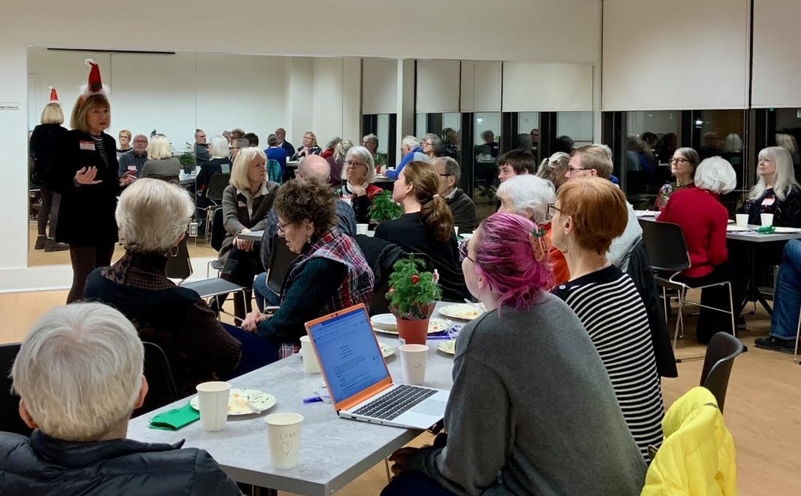
Your new League officers and board members are:
Corinne Shepherd | President
Cynthia Jorgenson | Treasurer
Jo Holub | Co-secretary
Terry Mackin | Co-secretary
Katharine Husted | Voter Services Chair
Denise Royer | Voter Registration and Outreach Co-chair
Deborah Capouch | Voter Registration and Outreach Co-chair
Nancy Claycomb | At-Large
Marcia Wattson | Communications

Civics Bee a Huge Success
The City-Wide Civics Bee Championship unfolded on January 31 in the City Council Chambers. Seven 7 th grade finalists, representing Oak Grove, Olson, and Valley View Middle Schools, vied for victory in this academic showdown. Mayor Tim Busse served as the event’s moderator, guiding the student contestants through a diverse array of civics-related questions. Thank you to Jane Linnee, Nancy Claycomb and Doug Claycomb for managing this program.
Following 13 intense rounds of questioning, Josiah Brecheisen from Olson Middle School clinched 1st place. Ryan Frischmon from Valley View Middle School secured 2nd place honors, while Sawyer Hand from Olson Middle School claimed 3rd place.
This prestigious competition was made possible through the collaborative efforts of the League of Women Voters – Bloomington, Bloomington Public Schools, City’s Community Outreach and Engagement Division. When asked why studying civics matters, Valley View Middle School Social Studies teacher, Greg Erbisch stated the following, “You can’t be successful in life unless you know the game and civics does that. It teaches you how to be a good citizen.”
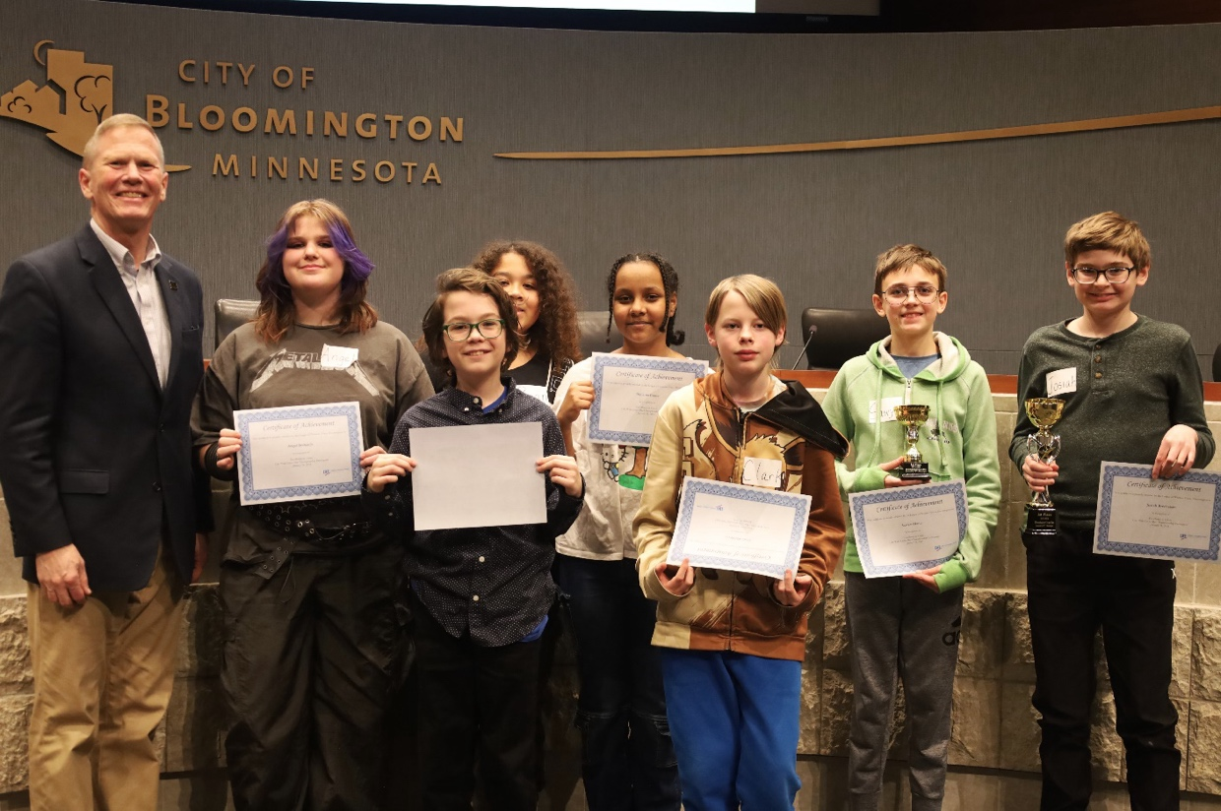

February 12, ERA in Action
On February 12, a group of Bloomington League members traveled to the State Capitol to show support for the ERA rally in the rotunda. Passage of the ERA amendment is one of the State League of Women Voters legislative priorities for 2024 and it “promotes the adoption of a ballot issue in 2024 or 2026 to add the ERA into the Minnesota State Constitution that is consistent with the positions of the LWV.” Thanks to members Marcia Wattson, Laura Calbone, Deborah Capouch, Jon Rasmussen, Katharine Husted, Denise Royer and Corinne Shepherd for representing the Bloomington League at the event.
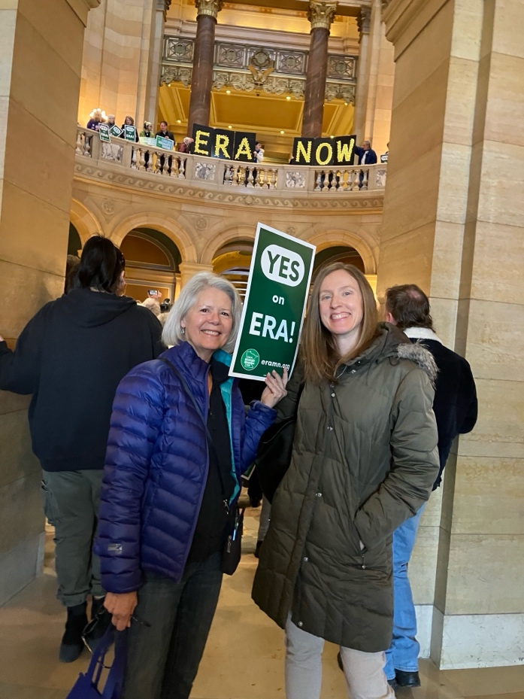
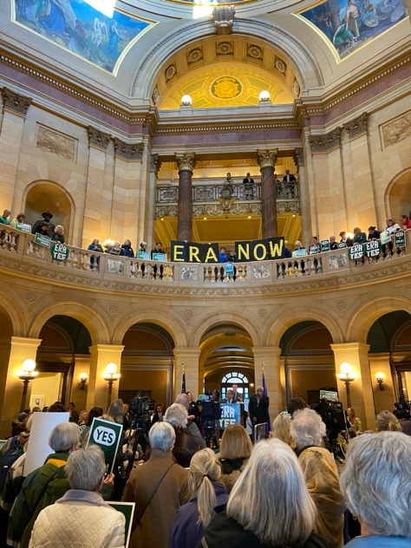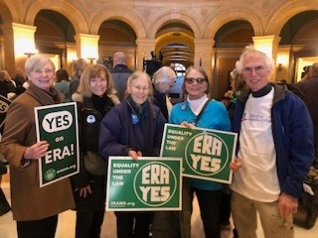
L – R Katharine Husted, Corinne Shepherd, Denise Royer, Deborah Capouch, Jon Rasmussen
L-R Marcia Wattson and Laura Calbone

February 20 Mock Election at Normandale Community College
LWV Bloomington members from the Voter Registration and Outreach Committee attended the Normandale Community College Mock Election on February 20. The NCC Student Senate organized this mock election to introduce students to the national Presidential Primary process. Secretary of State Steve Simon gave an overview of election laws and answered questions. Thanks to Sec. Simon and to Nancy Claycomb, Deborah Capouch and Denise Royer of LWVB for providing support to the students in having the confidence to take on this project.

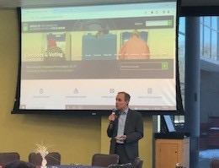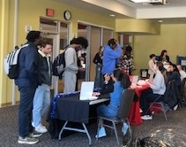

March 12 Member Meeting
Civics education is a key area of interest for the League. Mark your calendar for the upcoming meeting on March 12. Ashley Modrow, Director of Elementary Curriculum and Instruction and Beth Flottmeier, Director of Secondary Curriculum and Instruction for the Bloomington School District, will give us the inside scoop on Civics education in Bloomington schools. Another “not to be missed” meeting. Our League continues to meet in person as we enjoy the camaraderie of being together, but we also offer the option to join by phone or by zoom. Please join us to learn more!

Did you know….
- This year the State League will hold a State League Council. It is scheduled for:
- April 27 8:30 -12:00 and it is a virtual event. If you want to learn more about your State League and other leagues, plan to attend. More information will be available soon.
- LWVMN provides great learning opportunities for you all year? But especially in January, the League offers on-line learning called January Jumpstart. If you want to know more about the League, this is a good way to sample various topics. No worries if you missed it.: Session recordings and other resources are available.
  - https://www.lwvmn.org/january-jumpstart-2024?rq=jumpstart

Looking ahead….
- League members will have a table at the Metro South Adult Basic Education Community Resource Fair on March 5th. We will be sharing information about election laws and procedures and encouraging eligible voters to vote in the Presidential Primary. We will have information to help them find the location of their polling place and to learn about the League of Women Voters.
- LWVB will have a table at the 2024 Farmer’s Market on July 13 and September 14. We need volunteers for those events and others. It’s very fun and a great way to meet your Bloomington neighbors. Even if you have never volunteered at an event, you will be given an expert orientation.
- If you are aware of upcoming community events where you think LWVB initiatives would be a good fit (i.e. voter registration, voter education, opportunity to meet new and welcome new community members), let us know at lwvbloomington@lwvmn.org
- Thank you to all our League members who will be election judges on March 5. You play a key role in the successful election cycle. And for all members, vote early or vote on March 5th.
Thanks to all our members for supporting the League of Women Voters and for “making democracy work!”

WELCOME to our newest League members!
- Arlene Holdeman
- Wesley Friberg
- Anna Schmidt
- Alayna Skogland

