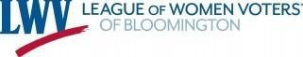
THE VOTER
BLOOMINGTON MN LEAGUE OF WOMEN VOTERS NEWSLETTER
ELECTION EDITION, NOVEMBER 2023

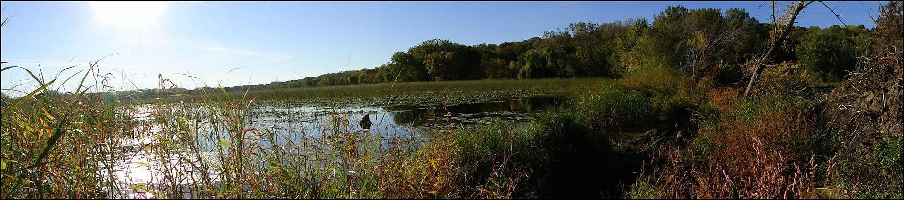
Welcome, members and friends of LWVB to our Newsletter!
__________________________________________________
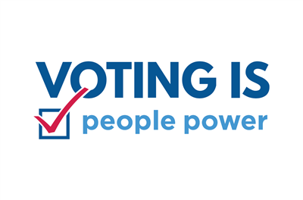
Quick Fact: Every election year, Minnesota leads the nation in voter participation!

Early voting for elections in Bloomington ends on Monday, Nov. 6 at 5pm. Those who have not voted by then can do so at their precinct polling place Tuesday between 7 a.m. and 8 p.m.

___________________________________________________
THE 2023 BLOOMINGTON ELECTION

Upcoming 2023 Election Dates
- On Tuesday, Minnesota voters will complete the work of the 2023 election in polling places around the state. In a return to pre-pandemic voting patterns, more of the vote — about 75 percent — will be in person on Election Day, rather than by mail or at early voting sites(source: LWV Minnesota).
- September 22 through November 6 Vote early in person
- The deadline to register in advance was October 17. Advance registration saves time on election day!
- November 7, 2023, ELECTION DAY
WHO CAN VOTE
- To vote in the election, residents must be U.S. citizens, at least 18 years old on Election Day and a Minnesota resident for at least 20 days as of Election Day.
- NEW As of June 1 of 2023, residents may vote even if they are on parole or probation. Their right to vote has been restored and felony status does not affect their right to vote if they are not serving a sentence in a correctional facility. If they have a felony conviction, they can vote while on work release, home monitoring, probation, or parole.
- Voters must re-register if they have moved to a different address, changed their name, or have not voted once within the past four years.
- To confirm that you are registered, go to the Secretary of State site at https://mnvotes.sos.mn.gov/voterstatuscheck/index

LWV REGISTERS NEWLY ENFRANCHISED VOTERS

On July 7, LWVMN, our state league, partnered with US Probation and Pretrial Services, Department of Corrections, and other community partners to host multi-site voter registration events in 6 cities (Mpls, St. Paul, Rochester, Duluth, Bemidji, and Fergus Falls), to support the voter registration and educational needs of our newly-enfranchised voters who have left prison behind. A special thanks to our local Leagues in Minneapolis, St. Paul, Rochester, Duluth, and Bemidji for their leadership of these successful events. LWV remains relevant and needed, as we work to implement the new election laws in support of our voters!

News coverage of our initiative: Fox9 News League of Women Voters Minnesota Partners with Department of Corrections and -Others to Host Voter Registration Events for Recently Enfranchised People.

Bloomington voters will have the following races on their ballots:
- Mayor
- City Councilmember At-Large
- City Councilmember At-Large (special election, two-year term)
- District Council Members (1-4)
- School Board Members (3)
- Three local sales tax questions

The Bloomington League of Women Voters hosted forums with each group of candidates:

view RECORDINGS OF candidate FORUMS
- Bloomington (ISD 271) School Board Candidate Forum
recorded September 13, 2023
- Bloomington City Council At-Large Candidate Forum
recorded September 19, 2023
- Bloomington Mayoral Candidate Forum
recorded September 19, 2023
- Bloomington City Council Candidate Forum
recorded September 20, 2023
Many voters tell us that the forum recordings are their best source of candidate information.
Photos from some of our forums:
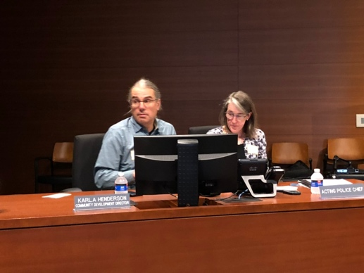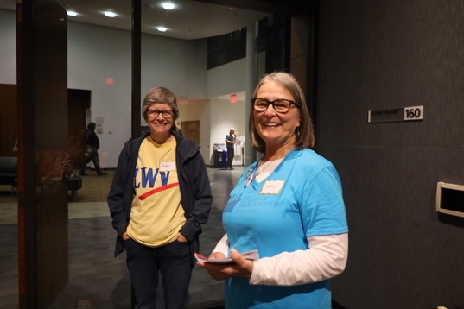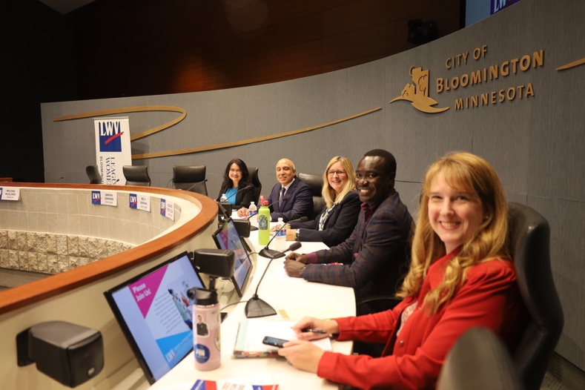
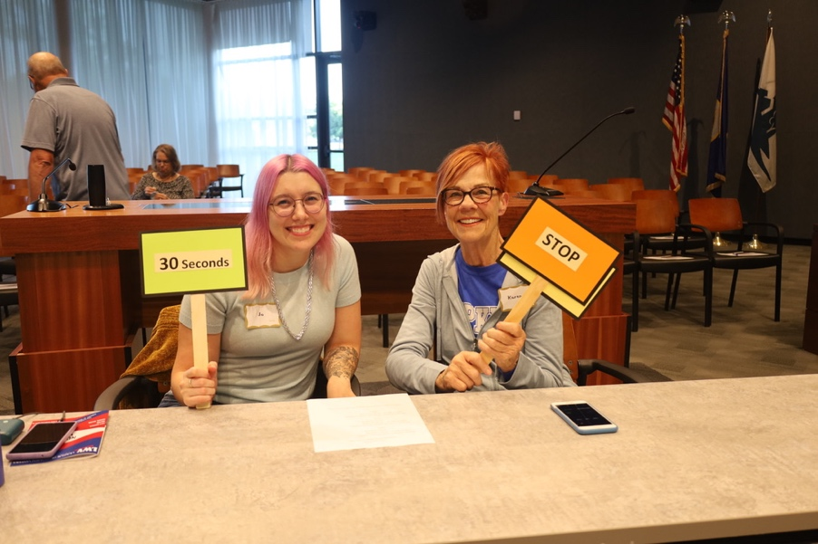

Statement on Candidate Forum Recordings
The League of Women Voters Minnesota and our local Leagues conduct candidate forums to provide the public with an opportunity to hear candidates discuss the issues that are important to members of the public. The League is a nonpartisan organization that does not support or oppose any political party or candidate. The views expressed in each forum are those of the candidates, not those of the League of Women Voters. LWV Minnesota and our local Leagues post complete, unedited recordings of forums. Editing is authorized only for official media reporting. Excerpts or edited clips of candidate forums may not be used for partisan or political purposes.
ADDITIONAL INFORMATION ON EACH CANDIDATE
Voting information for Bloomington residents is available online at tinyurl.com/bl23vote.
Bloomington City Council candidate profiles are available online at tinyurl.com/bcc23mn.
Bloomington School Board candidate profiles are available online at tinyurl.com/bsb23mn.
Information about Bloomington’s sales tax proposal is available online at tinyurl.com/bl23ballot.
WHEN TO VOTE
In Bloomington, early voting is available until 5PM Monday, November 6. Polls are open on Tuesday, election day evening until 8pm.
WHERE TO VOTE

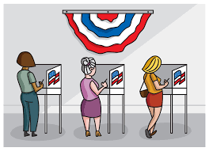

The map of Bloomington’s revised precinct and polling places is at
https://www.bloomingtonmn.gov/sites/default/files/2023-09/10_23bf_pg__08.pdf
Bottom of Form
Due to Minnesota’s recent redistricting, boundaries of districts and precincts within Bloomington have changed. Please check the current map.
Bloomington will use ranked choice voting for council candidates as it did in the last city election. For a refresher on “ranked choice voting” click on
https://www.bloomingtonmn.gov/cl/ranked-choice-voting. Other cities that use ranking voting in Minnesota include Minneapolis, St. Paul, St. Louis Park and Minnetonka.
The Bloomington school district (ISD #271) is also holding elections this fall. Six candidates are vying for three seats on the board. That race will not use ranked choice voting.
CANDIDATES. Click this link to see who is on the ballot:
https://www.bloomingtonmn.gov/cl/candidate-filing
School Board Elections Bloomington (ISD 271)
The term for a School Board member is four years. School Board members are elected in the odd years. The Bloomington School Board race features three incumbents and three challengers. It will not use ranked choice voting. The top three candidates will win the board’s three seats. Incumbents seeking reelection are Nelly Korman, Mia Olson, and Heather Starks. Challengers for the seats are Sandra Johnson, Ricardo Oliva and Langa Oriho.

ON THE BALLOT, YOU WILL ALSO VOTE ON 3 QUESTIONS
Bloomington Sun-Current
Bloomington has officially launched a new website – BloomingtonForward.org – designed to inform residents about a proposed $159 million investment in community amenities that bring residents together and enhance their quality of life. The website contains a broad range of details about a long-term City plan, called Bloomington Forward, to invest in three major capital projects that support health, wellness, athletics, and recreation in the community.

The city is seeking to finance (1) improvements to the Bloomington Ice Garden, (2) replacement of its community center and public health offices with a joint project and (3) restoration and enhancement of the Nine Mile Creek corridor through the sales tax. More detail at Bloomington’s web site https://www.bloomingtonforward.org/vote
Bloomington voters will consider three separate ballot questions — one for each of the three projects in the Bloomington Forward plan. If voters approve any of the ballot questions, a half-percent citywide sales tax will be authorized to fund the project.
If voters approve the ballot questions, a half-percent citywide sales tax will be authorized to fund the projects. Voters can approve using the half-cent sales tax option for each project separately. The projects are independent of one another. and the 0.5% sales tax is not added for each project. The duration of the tax will be determined by how many of the projects earn voter approval

HOW DO WE ENSURE INTEGRITY IN OUR MINNESOTA ELECTIONS?
For more than 100 years, the League of Women Voters has been a trusted source for nonpartisan voter registration and education, and a longstanding witness to Minnesota’s proud tradition of voter access and election integrity.

Sadly, misinformation following the 2020 elections, and continuing to the present day, is undermining voter confidence, and fueling dangerous hostility toward election officials and is also threatening to impede voter access and party-balance of election judges. We ask voters to ward off rumors and unfounded claims, and instead affirm the strong evidence you have at your disposal from across the political spectrum, which shows our elections were, and remain, fair and accurate.

PAST AND UPCOMING CLASSES AND EVENTS
October 28 CORNERSTONE ADVOCACY 40th ANNIVERSARY EVENT. Some of our volunteers participated recently in the 40th Anniversary celebration of Cornerstone Advocacy. Cornerstone is a non-profit organization that provides comprehensive services for victims/survivors experiencing domestic violence, sexual assault, human trafficking and exploitation. LWVB is a supporter of Cornerstone. More information about this innovative organization is available at info@cornerstonemn.org
Saturday November 11 Bloomington Farmer’s Market
Indoors, Bloomington Civic Plaza, 1800 West Old Shakopee Road
At Bloomington Civic Plaza farmers, growers, and producers sell their own products directly to the public. There will be additional winter indoor markets in December, February, and March.

Upcoming Events Sponsored by LWV Minnetonka, Eden Prairie, Hopkins

2023 Redistricting Update and Call to Action ​

WHEN: Saturday, Nov 18, 10:00 am
WHERE: Ridgedale Library, Meeting Room 172, 12601 Ridgedale Drive, Minnetonka, MN 55305
SPEAKER: Paul Huffman

November 14 Join us for a presentation by SAM STREUKENS, LWVMN Civic Engagement Director
Tuesday, November 14, Sam completed his master’s in advocacy and political leadership from Metro State University, after earning a Bachelor’s in Global Studies from Winona State University and serving a short stint in the Peace Corps.
Sam will talk about his advocacy role with the League of Women Voters Minnesota. And the voting legislation passed during the recent legislative session.

________________________________________________________
Kennedy High School Voter Registration
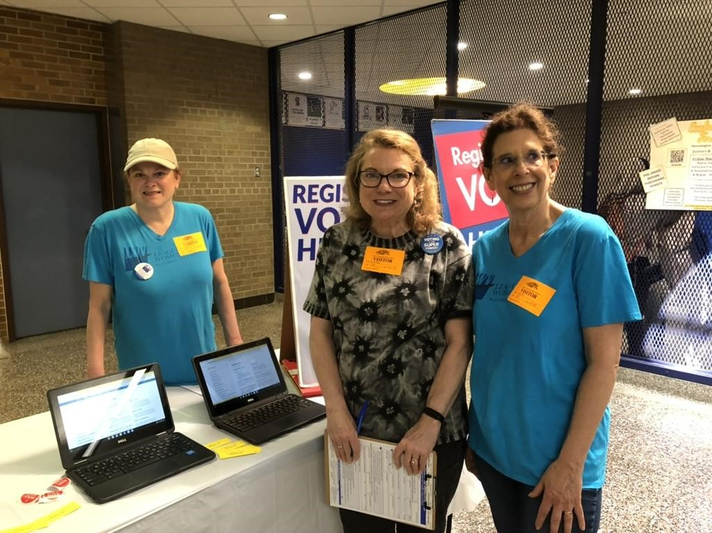
Our Voter registration volunteers were at Kennedy High school in May. It was fun to register new voters and try to stump them with our “spin the wheel quiz. L-R Chris Clark ( Committee co-chair ), Lauren Braswell, Cindy Royce. Thank you, volunteers! We also registered students at Jefferson High School.

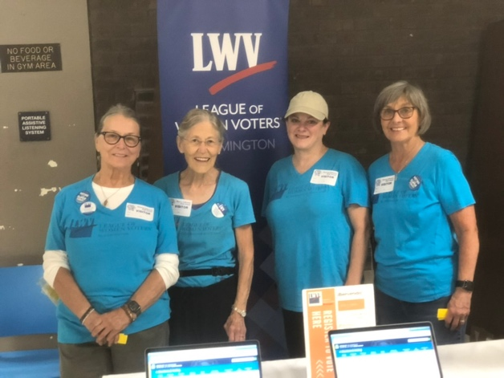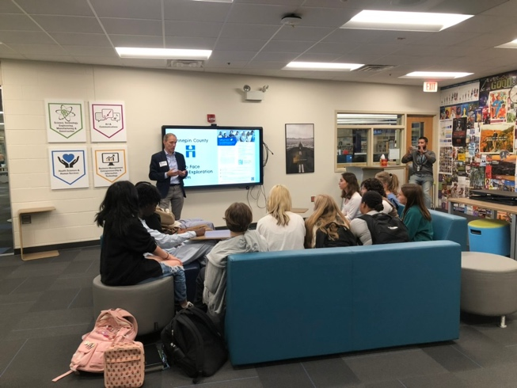
Jefferson High School Voter Registration
Voter registration volunteers were also at Jefferson High School on September 22 to coincide with the Secretary of State Steve Simon’s visit to Civic Plaza and the High School. Simon met with students in the Career Center and talked about the importance of voting and how they can get involved in elections and voting.
Left: Deborah Capouch, Denise Royer, Chris Clark, Sarajane Meyers
Right: Secretary of State Steve Simon at the Career Center

**JOIN THE BLOOMINGTON LEAGUE OF WOMEN VOTERS!**
The League of Women Voters Minnesota is a nonprofit, nonpartisan organization committed to civic engagement. Membership is open to all genders ages sixteen and up.

Through our partnership with LWV United States, our State LWVs, and other community
organizations, we encourage informed and active participation in government, register and inform voters, work to increase understanding of major public policy issues, and influence public policy through education and advocacy. All our work is done with an equity and inclusion lens, to ensure that all people have a voice and are represented in our democracy.

CONNECT WITH LWVB!
TO JOIN, go to our LWVB website below:
Website and Newsletter: https://lwv-bloomington.com
Facebook: https://www.facebook.com/LWVBloomingtonpage/
Email: lwvbloomington@lwvmn.org

Loss of Kaye Aho
Bloomington recently lost Kaye Aho, a beautiful soul, effective leader, advocate, and friend to many. She was president of the Bloomington League Unit from 2011 to 2015. We are thankful for our time with her. Mary Rice, Past-President of LWVB 2015-2019 reflected on Kay’s contributions to the city. In her tribute, Mary describes the early history of LWVB and how it grew from 15 members to over 60 in a few short years. The tribute follows.

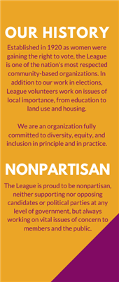
-------------------------------------------------------------------------------------------------------------------------------------------------
Kaye Aho and LWV Bloomington
In memory of Kaye Aho, who died July 11, 2023
Kaye Aho was president of the Bloomington League Unit from 2011 to 2015. While she was president and largely through her efforts, LWVB’s membership grew from about 15 members to over 60. LWVB held forums, implemented candidate videos, and continued with its Salad Supper, an annual gathering of LWVB members, local officials, and political candidates for food, talk, entertainment, and short stump speeches. It hosted public forums on issues ranging from early childhood education to immigration. Kaye created and expanded LWVB’s youth membership and became a mentor to several of the young members.
The Bloomington League was not yet a local league during Kaye’s presidency. Before becoming a local league, a group begins as a local unit. Once unit membership is large enough and has some stability, a unit can, with approval of the national and state Leagues, incorporate as a local League, with bylaws, a board, officers, convention delegates, etc. Toward the end of Kaye’s presidency, the Bloomington unit planned to apply to become a local League. To do that, bylaws had to be created. LWV requires that many provisions of state and local League bylaws mirror the national bylaws. The membership provisions of those bylaws required that voting members of the League be at least 18 AND citizens. Kaye refused. Some of our members were under 18 and some were not citizens, and she believed the bylaw requirements were contrary to one of the primary purposes of the League, to promote active civic engagement for everyone. The members of the Bloomington local unit agreed with her.
Carol Frisch, past Minnesota League president, had recently moved to Bloomington and become a Bloomington League Unit member. Carol attended the LWVMN Convention and successfully moved that the State League support a motion at the 2016 National LWV Convention to change the national LWV (and therefore every state and local League) bylaws to remove the citizenship and age requirements for voting membership.
The game was on. The Bloomington League Unit, with assistance from LWV Edina and LWV White Bear Lake, led the charge, with support from LWV Minnesota and LWV California.
- One group consisting of members of the Bloomington unit, LWV Edina and LWV White Bear Lake, contacted every state and local League in the country by email to explain and promote the proposed bylaw amendments, and called state League presidents. Campaign pins were created, and a workshop session was scheduled at the national convention before the vote.
- Critical to the success of the effort, Kaye worked with four young members (one was under 18 and two were not citizens) to prepare for and attend the national convention in support of the amendments.
Two of the young members, Claire Schlichting and Xiaojing Zeng, spoke at the workshop and then made the moving speeches on the Convention floor on behalf of LWV Minnesota, the moving League. Xiaojing spoke eloquently in favor of removing the citizenship requirement, and following many comments by various delegates, the motion passed overwhelmingly. Claire spoke with similar eloquence in support of removing the age requirement. After many comments for and more against, but with the assistance of LWV White Bear Lake parliamentarian Miriam Simmons, the final vote was a compromise, reducing voting membership to the age of 16.
The remainder of the convention, Kaye took the students to visit our House and Senate representatives, and other places of significance to them as young people interested in civic engagement.
Upon our return from the National Convention, we applied and were approved for local league status. LWV, every state league, and every local league, amended their bylaws to remove the citizenship requirement for voting membership and to reduce the age requirement from 18 to 16. That would not have happened without Kaye’s initial refusal to go along with the existing bylaw requirements and her mentorship of the young members who were instrumental in pushing the amendments through at the Convention. Thank you, Kaye!
Mary Rice
Past-President 2015-2019

